**Creto | eCommerce HTML Template**

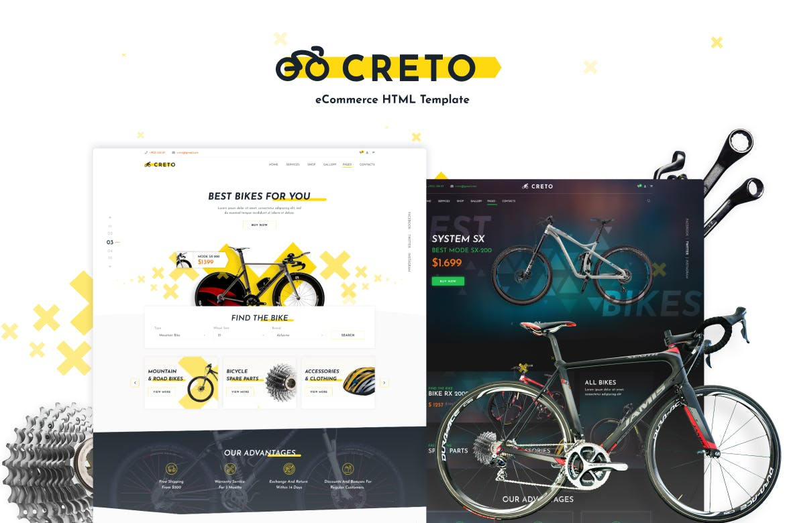

Creto is the right choice for your business if you want a really comprehensive solution. This template covers all the needed features for a creative website and this is a highly suitable one for companies that offer rental services as well as other bicycle-related services. Everything is clear and easy to customize with tons of useful visual page builder elements which is well-organized in set predefined layouts. Turn your idea into reality.

**HTML5**

Perfect solution with fully customized layouts and well structured HTML5 code. The code is super easy to understand and create something unique

**CSS3**

Maintain all template styles with understandable CSS. ( For the great customizing flexibility SASS source files included. )

**Responsive**

Great experience with responsiveness to all popular resolutions. Perfectly scalable on all popular devices.

**Cross Browser**

We’ve covered cross-browser compatibility for a variety of browser and OS version combinations to ensure they work perfectly whatever your visitors are using.

**Google Fonts**

The most popular font set included. A variety of free Google fonts makes your customization in the easiest way.

**W3C Validate**

We’ve performed W3C validation for browser compatibility and site usability

**SEO Friendly Code**

Complete SEO optimization for better speed performance. Using best coding practices we let our templates load really fast an be more friendly to search engines.

**Support**

We always care about our customers, our loyal support team are always ready to help

**Features List**

* True responsiveness
* Cross Browser Compatibility
* Easy to customize
* Google Fonts
* Clean & Commented Code
* Custom Font Support
* Touch Enabled Sliders
* Html5 and Css3
* W3C Validate
* Well Documented
* Sticky Header
* Parallax effect
* Social links
* Google Map
* Dynamic contact form
* Blog Pages
* Background video

**Sources and Credits**

* Fonts Used: Google Fonts
* Images: depositphotos.com – All rights reserved! ( Images not included in the template-package )
* JavaScripts: Jquery, Fancy Box, Masonry, Slick
* Icons: Font Awesome

###### Item tags

[**Bicycle**](https://elements.envato.com/web-templates/bicycle)

[**Bicycle**](https://elements.envato.com/web-templates/bicycle)

[**Sharing**](https://elements.envato.com/web-templates/sharing)

[**Bike**](https://elements.envato.com/web-templates/bike)

[**Bike**](https://elements.envato.com/web-templates/bike)

[**Rent**](https://elements.envato.com/web-templates/rent)

[**Catalog**](https://elements.envato.com/web-templates/catalog)

[**Ecommerce**](https://elements.envato.com/web-templates/ecommerce)

[**Online**](https://elements.envato.com/web-templates/online)

[**Store**](https://elements.envato.com/web-templates/store)

[**Rental**](https://elements.envato.com/web-templates/rental)

[**Retail**](https://elements.envato.com/web-templates/retail)

[**Shop**](https://elements.envato.com/web-templates/shop)

[**Wheels**](https://elements.envato.com/web-templates/wheels)